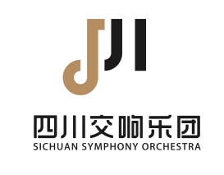 Application Form for Recruitment
of Sichuan Symphony Orchestra
Name |  | Birthday |  |  | Photo
Gender |  | Nationality |  |  | Photo
Degree |  |  |  |  | Photo
Tel./Email |  |  |  |  | Photo
Education
(Please indicate year of graduation)
Passport No.
Major
Position Applying For
Do you accept adjustments |  |  | YES NO
Resume
Awards and Certifications

